SUPLEMENTAL MATERIAL

Table 1

*Participant clinical details.*

|  |  |  |  |  |  |  |
| --- | --- | --- | --- | --- | --- | --- |
| SID | Age, Gender | Dx | Visual acuity | Ocular alignment | Refractive error | Fixation |
| AA1 | 24, M | Aniso | OD: 20/16  OS: 20/25 +1 | Far: ortho  Near: 4 EP | OD: +1.25 -1.00 x002  OS: +4.25 -1.50 x170 | Central |
| AA2 | 18, F | Aniso | OD: 20/25 -1  OS: 20/20 +1 | Far: ortho  Near: ortho | OD: +1.25 -1.25 x188  OS: +0.25 -0.25 x009 | (-) EF |
| AA3 | 25, F | Aniso | OD: 20/20 +1  OS: 20/16 | Far: 4 EP  Near: 5 EP | OD: +3.00  OS: plano | Central |
| AA4* | 62, M | Aniso | OD: 20/40 -2  OS: 20/20 -1 | Far: ortho  Near: ortho | OD: +7.75 -2.25 x085 (add 2.25)  OS: +5.25 -1.50 x105 (add 2.25) | Central |
| AMS1* | 21, M | Strab | OD: 20/25 -2  OS: 20/50 -2 | Far: ortho  Near: ortho | OD: +5.50 -4.75 x008  OS: +5.75 -5.00 x172 | Central |
| AS1 | 36, F | Strab | OD: 20/20  OS: 20/20 -1 | Far: 4 RET  Near: 4 RET | OD: -0.50 DS  OS: -0.25 DS | Central |
| AS2 | 30, F | Strab | OD: 20/20 -1  OS: 20/20 -1 | Far: 2 LET  Near: 4 LET | OD: +3.25 -1.25 x170  OS: +3.50 -1.25 x010 | 0.5 pd temp OS fixation |
| AS3 | 20, M | Strab | OD: 20/20 -2  OS: 20/20 -1 | Far: trace XP  Near: 6 XP | OD: +0.50 -0.50 x180  OS: plano -1.00 x180 | Central |
| AS4 | 54, M | Strab | OD: 20/25 -1  OS: 20/20 -1 | Far: 14 RET 5 HoT  Near: 6 LET 10HyT | OD: -1.00 -0.75 x160  OS: -1.00 -1.00 x020 | Central |
| ASW1 | 22, F | Normal | OD: 20/20 +1  OS: 20/16 -2 | Far: trace XP  Near: 2 XP | OD: -4.25 -1.00 x180  OS: -4.00 -0.75 x160 | Central |
| N1 | 25, F | Normal | OD: 20/16 -1  OS: 20/16 -1 | Far: ortho  Near: ortho | OD: -3.75 -0.75 x174  OS: -4.25 -0.50 x003 | Central |
| N2 | 26, F | Normal | OD: 20/20  OS: 20/20 | Far: ortho  Near: ortho | OD: -6.25 -0.25 x085  OS: -6.25 -0.25 x085 | Central |
| N3 | 28, M | Normal | OD: 20/20 -2  OS: 20/20 | Far: ortho  Near: ortho | OD: plano  OS: plano | Central |
| N4 | 24, F | Normal | OD: 20/25 +1  OS: 20/25 +2 | Far: ortho  Near: 2XP | OD: plano  OS: plano | Central |
| N5 | 28, F | Normal | OD: 20/20 +2  OS: 20/20 +2 | Far: ortho  Near: ortho | OD: -0.50 -2.25 x107  OS: -0.50 -2.25 x078 | Central |
| N6 | 23, F | Normal | OD: 20/16 -2  OS: 20/16 -1 | Far: trace XP  Near: 3 XP | OD: -3.25  OS: -3 | Central |
| N7 | 23, F | Normal | OD: 20/20 +2  OS: 20/20 | Far: trace XP  Near: 3 XP | OD: +0.25 -1.50 x177  OS: +0.25 -1.25 x176 | Central |
| N8 | 24, F | Normal | OD: 20/20 -1  OS: 20/20 | Far: 2 XP  Near: 6 XP | OD: -5.25  OS: -7.5 | Central |
| N9 | 23, F | Normal | OD: 20/16 -1  OS: 20/16 | Far: ortho  Near: 4 EP | OD: -1.00 DS  OS: -1.00 DS | Central |
| N10 | 24, F | Normal | OD: 20/16  OS: 20/12.5 | Far: ortho  Near: ortho | OD: -1.75 DS  OS: -1.75 DS | Central |

AA = Participants with anisometropia (n = 4); AMS = Micro-strabismic participant (n = 1); AS = Participants with strabismus (n = 4); ASW = Stereo-weak participants with otherwise normal binocular vision (n = 1); N = Stereo-normal participants (n = 10); * = participants with amblyopia.

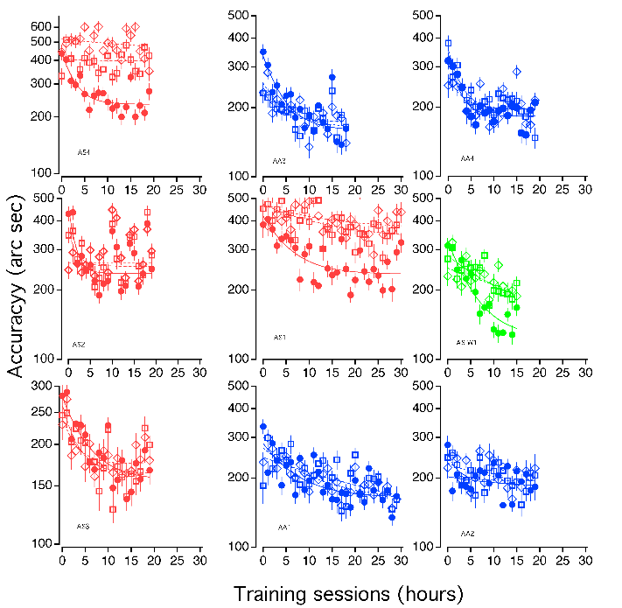

Figure 1. Participant game performance. Level 1 is represented as solid circles, Level 2 as hollow squares, and Level 3 as hollow diamonds. (A) In-game stereoacuity performance for stereo-normal participants. (B) In-game stereoacuity performance for stereo-anomalous participants. Colors represent binocular condition (Red: Strabismus, Blue: Anisometropia, and Green: Stereo-weak).

Table 2

*DartBoard in-game accuracy of a normal sighted participant in two scenarios: binocular vision (BV) and monocular vision (MV) by means of a physical patch. Time of game play 15 minutes in both cases. Condition (Level 1, 2 and 3); total number of trials; percentage of successful hits towards de board; median accuracy and interquartile range (seconds of arc); dichoptic task errors (per 100 trials)*

|  |  |  |  |  |  |  |  |  |
| --- | --- | --- | --- | --- | --- | --- | --- | --- |
|  | Trials | | Hits (per 100 trials) | | Accuracy (arc secs) | | Dichoptic errors | |
|  | BV | MV | BV | MV | BV | MV | BV | MV |
| Level 1 | 23 | 14 | 100 | 78.6 | 201 [106 – 333] | 583 [308 – 753] | 0 | 14 |
| Level 2 | 22 | 19 | 100 | 84.2 | 251 [157 – 396] | 566 [402 – 915] | 0 | 26 |
| Level 3 | 24 | 19 | 100 | 63.2 | 165 [56 – 331] | 363 [230 – 860] | 42 | 53 |

Table 3

*Halloween in-game accuracy of a normal sighted participant in two scenarios: binocular vision (BV) and monocular vision by means of a physical patch (MV). Time of game play 15 minutes in both cases. Condition (level 1, 2 and 3); total number of trials; successful trials (per 100 trials); dichoptic task errors (per 100 trials)*

|  |  |  |  |  |  |  |  |  |  |  |
| --- | --- | --- | --- | --- | --- | --- | --- | --- | --- | --- |
|  |  | Trials | | | Successful trials  (per 100 trials) | | | Dichoptic errors  (per 100 trials) | | |
|  |  | Level 1 | Level 2 | Level 3 | Level 1 | Level 2 | Level 3 | Level 1 | Level 2 | Level 3 |
| Overall | BV | 146 | 141 | 133 | 92 | 89 | 86 | 2 | 1 | 3 |
| MV | 133 | 136 | 118 | 77 | 61 | 65 | 10 | 10 | 12 |
| 1000” | BV | 18 | 18 | 18 | 100 | 100 | 100 | 0 | 0 | 0 |
| MV | 18 | 22 | 26 | 100 | 82 | 69 | 0 | 0 | 0 |
| 650” | BV | 18 | 20 | 19 | 100 | 90 | 95 | 0 | 5 | 5 |
| MV | 19 | 114 | 44 | 95 | 57 | 70 | 5 | 12 | 18 |
| 420” | BV | 19 | 18 | 22 | 95 | 100 | 77 | 5 | 0 | 14 |
| MV | 21 |  | 48 | 86 |  | 58 | 10 |  | 13 |
| 270” | BV | 24 | 27 | 25 | 100 | 89 | 96 | 0 | 0 | 0 |
| MV | 33 |  |  | 73 |  |  | 9 |  |  |
| 180” | BV | 25 | 27 | 26 | 96 | 85 | 92 | 4 | 0 | 0 |
| MV | 42 |  |  | 60 |  |  | 17 |  |  |
| 120” | BV | 31 | 31 | 23 | 77 | 77 | 61 | 3 | 0 | 0 |
| MV |  |  |  |  |  |  |  |  |  |
| 80” | BV | 11 |  |  | 82 |  |  | 0 |  |  |
| MV |  |  |  |  |  |  |  |  |  |

Table 4.

*d’ PPR for each participant, cue scaffolding level, and stereoacuity demand.*

|  |  |  |  |  |  |  |  |  |  |  |  |  |
| --- | --- | --- | --- | --- | --- | --- | --- | --- | --- | --- | --- | --- |
| SID | Level 1 | | | | Level 2 | | | | Level 3 | | | |
| 1000” | 800” | 600” | 400” | 1000” | 800” | 600” | 400” | 1000” | 800” | 600” | 400” |
| AA1 | 1 | 1.28 | 1.07 | 0.93 | 0.84 | 1.1 | 1.29 | 1.29 | 1 | 1.01 | 1.11 | 0.93 |
| AA2 | 1.15 | 1.11 | 1.18 | 1.45 | 1.11 | 1.11 | 1.02 | 1.5 | 0.8 | 1.25 | 1.63 | 2.05 |
| AA3 | 0.99 | 1.10 | 1.17 | 1.29 | 1 | 1.06 | 1.18 | 0.91 | 0.99 | 1.12 | 1.24 | 1.22 |
| AA4 | 0.99 | 2.37 | 1.55 | 1.49 | 0.99 | 2.06 | 1.83 | 1.3 | 1 | 1.53 | 1.63 | 0.77 |
| AMS1 | 1 | 1.48 | 0.97 | 1.08 | 1 | 1.18 | 1.22 | 1.1 | 1 | 1.37 | 1.36 | 1.16 |
| AS1 | 1 | 1.71 | 1.42 | 1.77 | 1.59 | 1.4 | 1.5 | 1.7 | 1.6 | 1.3 | 2 | 0.76 |
| AS2 | 0.9 | 3.65 | 2.63 | 1.91 | 1 | 3.04 | 2.43 | 1.1 | 1.08 | 3.07 | 2.92 | 1.18 |
| AS3 | 1 | 1.04 | 1.03 | 1.34 | 0.76 | 0.9 | 0.96 | 1.19 | 0.76 | 0.88 | 0.89 | 1 |
| AS4 | 1 | 1.45 | 1.45 | - | 2.28 | 1.79 | - | - | 1.35 | 1.53 | 0.38 | - |
| ASW1 | 1.01 | 1.15 | 1.14 | 1.18 | 1.2 | 1.2 | 0.97 | 1.1 | 1.12 | 1.1 | 1.16 | 0.88 |
| N1 | 0.9 | 1.11 | 1.12 | 1.1 | 1.01 | 0.87 | 1.15 | 1.2 | 0.94 | 0.74 | 1.12 | 1.22 |
| N2 | 1.01 | 1.4 | 1.4 | 1.05 | 1 | 1.19 | 1.38 | 1.46 | 1.06 | 1.27 | 1.31 | 0.95 |
| N3 | - | 1.03 | 0.98 | 1.09 | - | 0.66 | 1.06 | 0.85 | - | 0.76 | 0.91 | 1.17 |
| N4 | 1.12 | 1.4 | 1.36 | 1.35 | 1.25 | 1.45 | 1.28 | 2.2 | 1.07 | 1.2 | 1.5 | 0.54 |
| N5 | 1 | 0.98 | 1.24 | 1.13 | 1 | 0.92 | 1.2 | 0.97 | 1 | 1.05 | 1.23 | 1.02 |
| N6 | 1 | 1.05 | 1.04 | 0.88 | 1 | 1.02 | 1.22 | 1.37 | 1 | 1.17 | 1.27 | 1.31 |
| N7 | 0.9 | 0.85 | 1.17 | 1 | 0.74 | 0.75 | 0.87 | 1.08 | 0.63 | 0.7 | 0.84 | 0.82 |
| N8 | 1.06 | 1.33 | 1.43 | 0.83 | 1.22 | 1.14 | 1.13 | 1.27 | 1.22 | 0.95 | 1.26 | 1.64 |
| N9 | - | 0.92 | 1.75 | 129 | - | 0.99 | 1.01 | 1 | - | 0.73 | 1.05 | 1.19 |
| N10 | 1 | 0.93 | 1.11 | 1.53 | 1.01 | 0.85 | 1.07 | 1.06 | 1.01 | 0.92 | 1.07 | 1.02 |